WP2.4
Project | BATSAT, The Community Sat | Phase :
WP Title : | Power Budget | WP number |  | 4
WP Title : | Power Budget | Issue : |  | 0 | Date : | 10/04/2020
Supplier | PM
WP Manager | @Team Leads Avionics
Start Event
End Event
Objectives :
To know how much energy we should be able, to produce, stock and use on the sat
Task Description :

- Calculate the maximum solar production capacity on sat over 24 hours (similar to OAP), taking into account the budget needed to access overperforming cells, the surface area required and the relative position to the sun.

- Calculate the necessary energy storage capacity for satellite operation over 24 hours.

- Deduce the maximum power allowed for the electronic system of the satellite.

- Estimation of the number of days of electrical life, taking into account the loss of battery efficiency as a function of the number of cycles.

Inputs :
Orbit Model
Cubesat 101 EPS Parts
Interfaces/links with others tasks or WPs: |  | Applicable requirements, standards, regulation constraint
Outputs :
Satellite's energy capacity Reports
Notes on the reliability of the system with respect to the chosen orbit and thus the position in relation to the sun.

Sat Energy Capacity Reports

This is the OPA Report, OAP is the average orbit power. We assume that the sat is in SSO orbit, which mean that the sat is always in sun zone. We assume two that the satellite is only rotation on one axis relative to the sun.
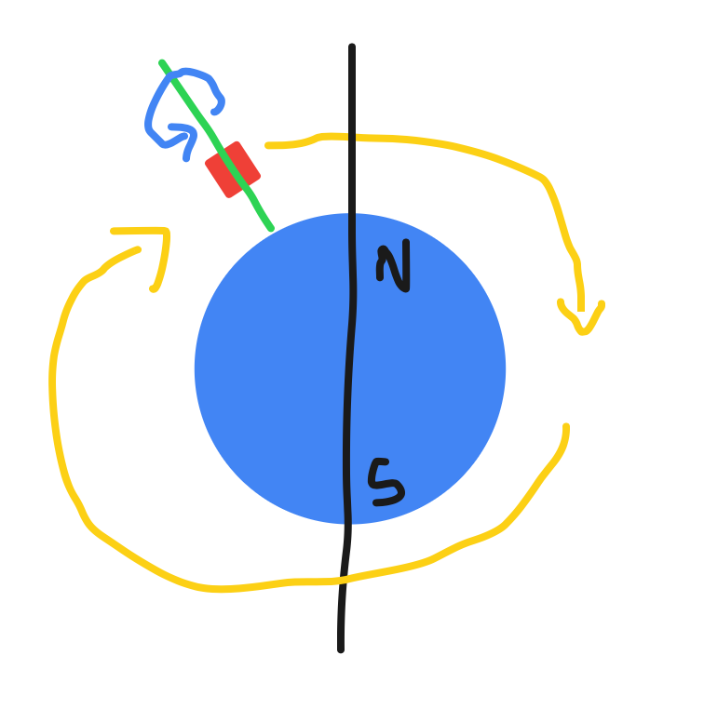

On the sat we have solar panel, on each face, to calculate the OAP, we want to know the average power that the solar panel will provide

To do that’s we need to calculate the average projected area of the sat during its rotation on its axis.

The formula to calculate the exposed area is this one :

Where A and B are the area of the face and the rotation of the sat (moving between 0 and 90°)

And then we just want to calculate the average value of the function on interval (0;90)
We first calculate the integrale and then divide it by delta of (90)

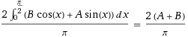

And the result are :

for A = 50cm2 and B = 50cm2
P = (2*(100))/pi = 63.66 cm2

for A = 50cm2 and B = 100cm2
P = (2*(150))/pi = 95.4 cm2

The first result if for the sat rotating with the big face on top (1)

The second result if for the sat rotating with a small face on top (2)
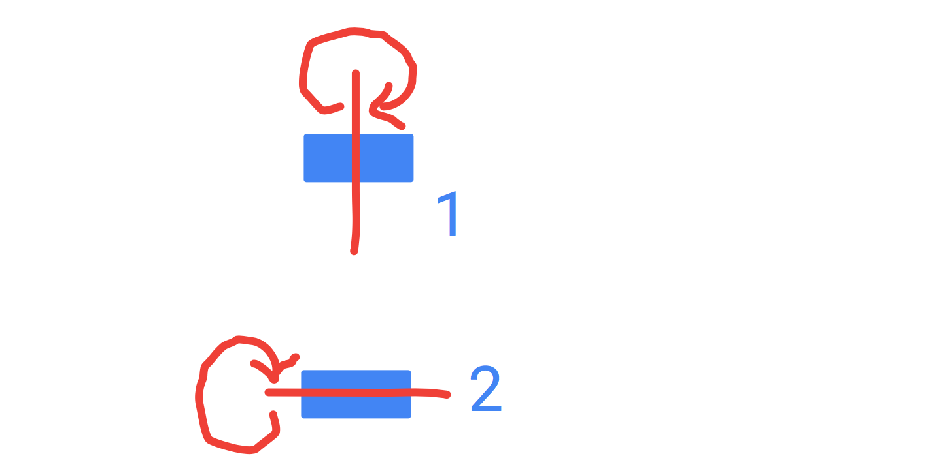

Then we know that the area used by solar panel on face is about 70%, and that solar efficiency is about 25%. We finally know that the solar power received by the sat will be about 1300W.m2 = 0.13W.cm2

OAP = (((Average projected area)*70%)*0.13)*25%

OAP1 = ((63.66*70%)*0.13)*25%
OAP1 = 1.448W

OAP2 = ((95.4*70%)*0.13)*25%
OAP2 = 2.170W

As we always have sun a big capacity battery is not required

Now it’s better to do the calculation with actual solar cell. We may use this one http://www.azurspace.com/images/0003429-01-01_DB_3G30C-Advanced.pdf

Surface area = 30.18cm2 = 60% of the face area
Efficiency = 28 %

OAPreal1 = ((63.66*60%)*0.13)*28%
= 1.390W

OAPreal2 = ((95.4*60%)*0.13)*28%
= 2.083W

